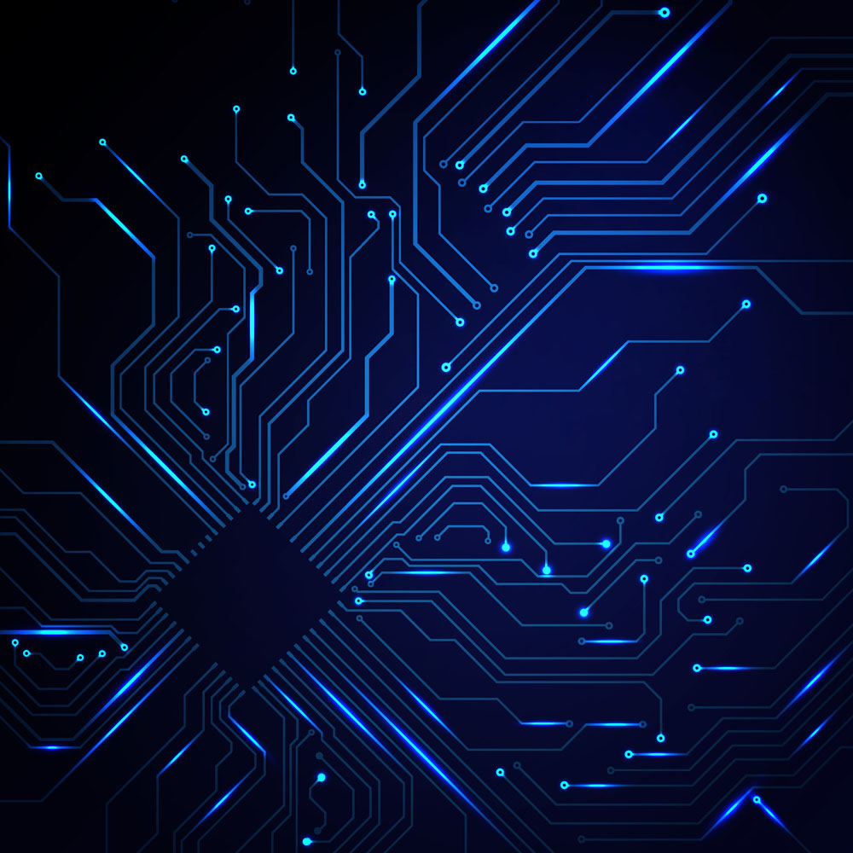  lab8  COUNTER  Name : 黃翊宏 Student ID : 01357101 |  | Note  - All files must be converted to PDF format before submission.  Submission deadline: Next Tuesday at 1:00 PM  Each person submits one assignment.

※Please use Win + Shift + S for screenshots. Do not take photos of the screen with a phone.
- Lab 8-1：

Main Code Screenshot
counter.sv:
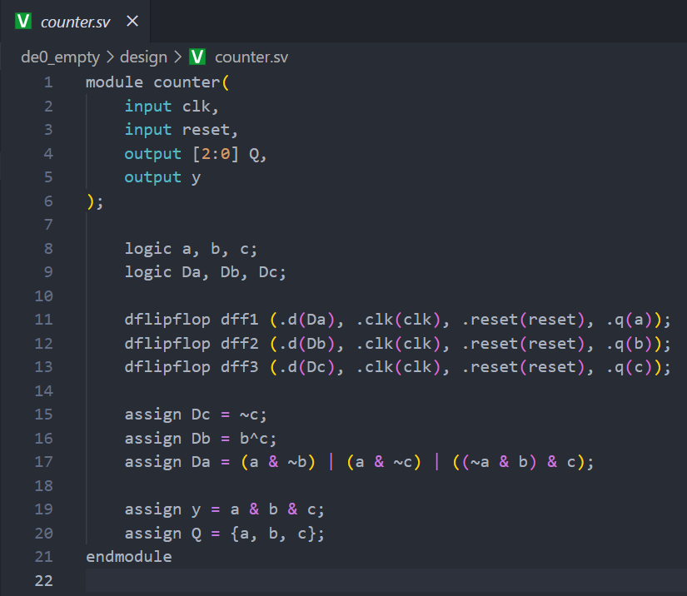
dflipflop.sv:
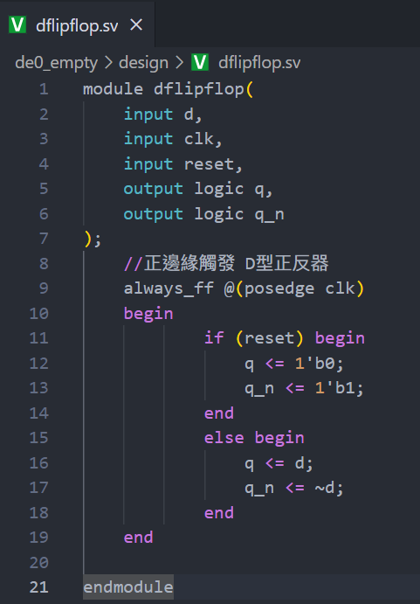
Testbench Screenshot
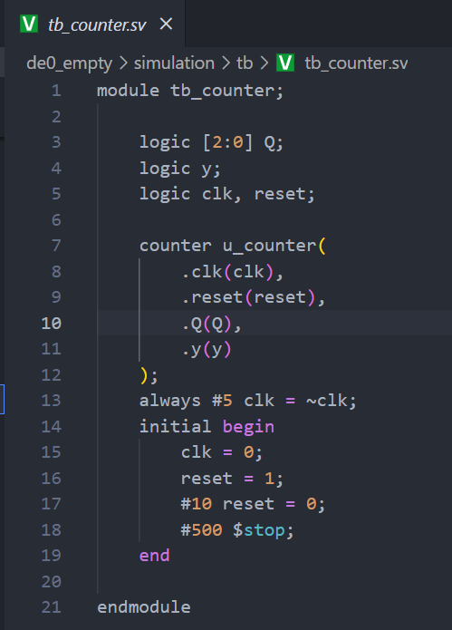
mcu.sv Code Screenshot
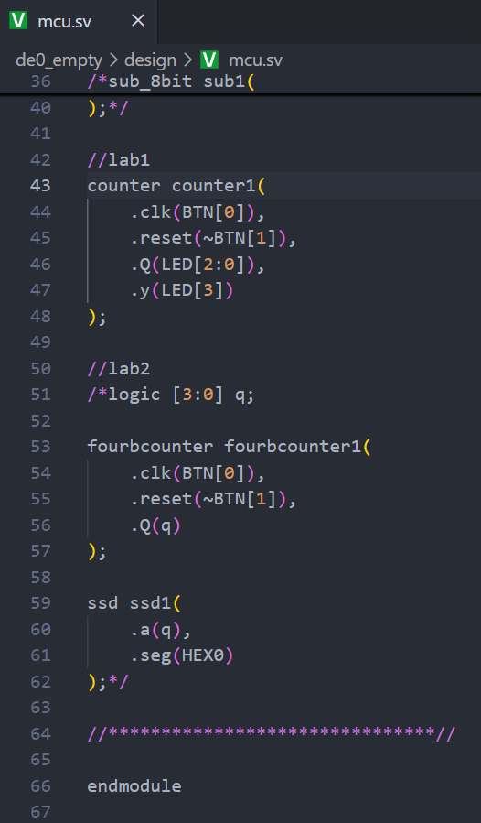
Waveform and Result Screenshot
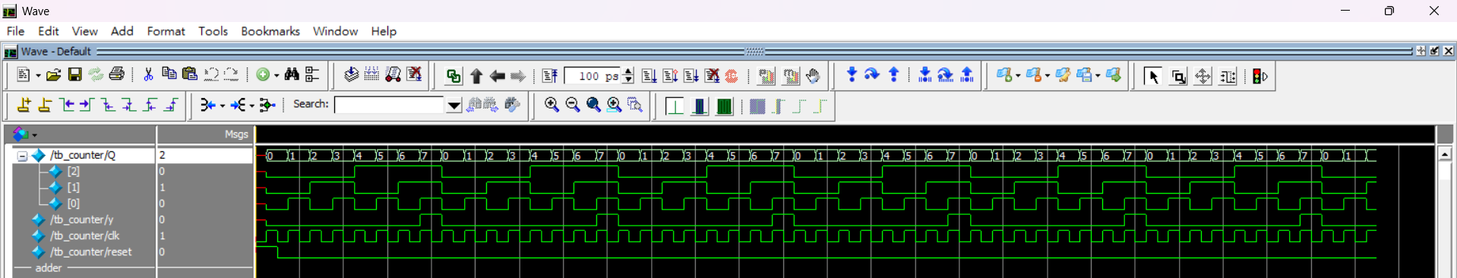

- Lab 8-2：

Main Code Screenshot
fourbcounter.sv
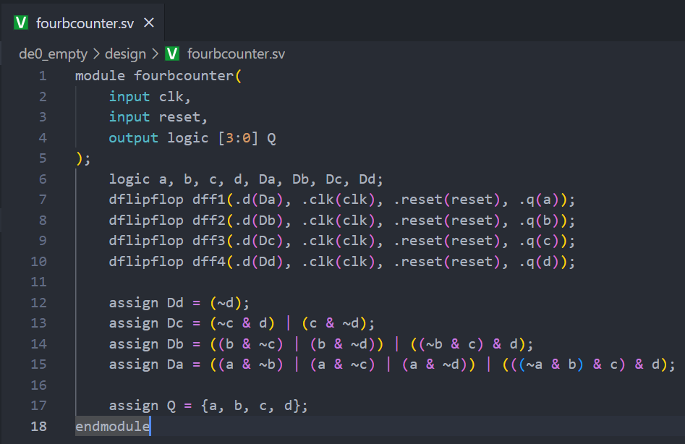
dflipflop.sv same as the Lab1.
Testbench Screenshot
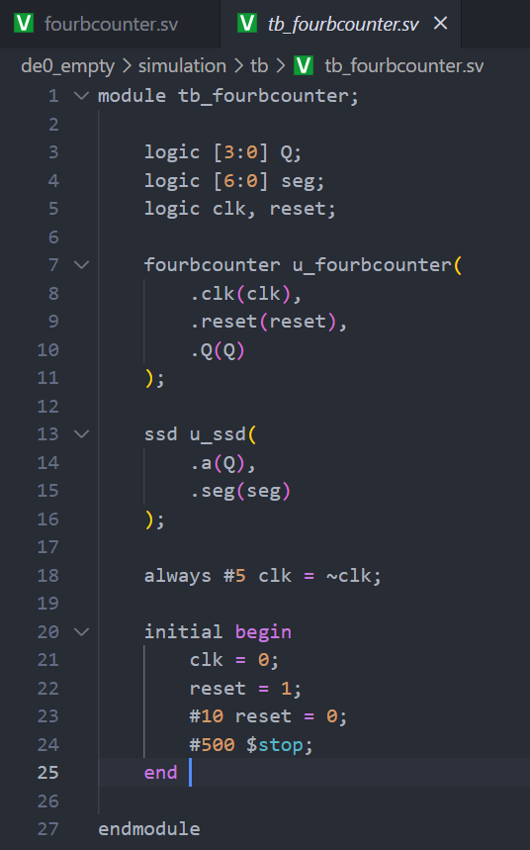
mcu.sv Code Screenshot
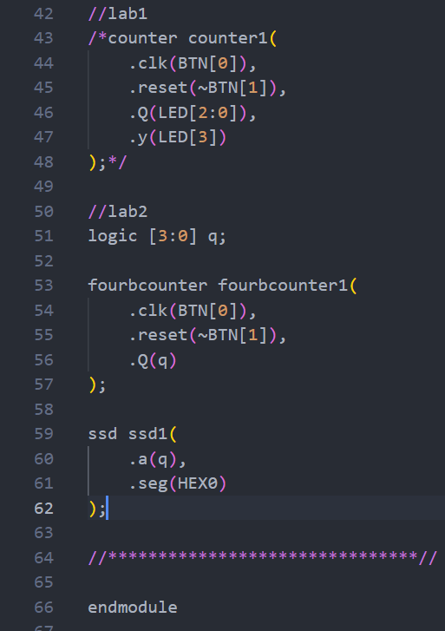
Waveform and Result Screenshot
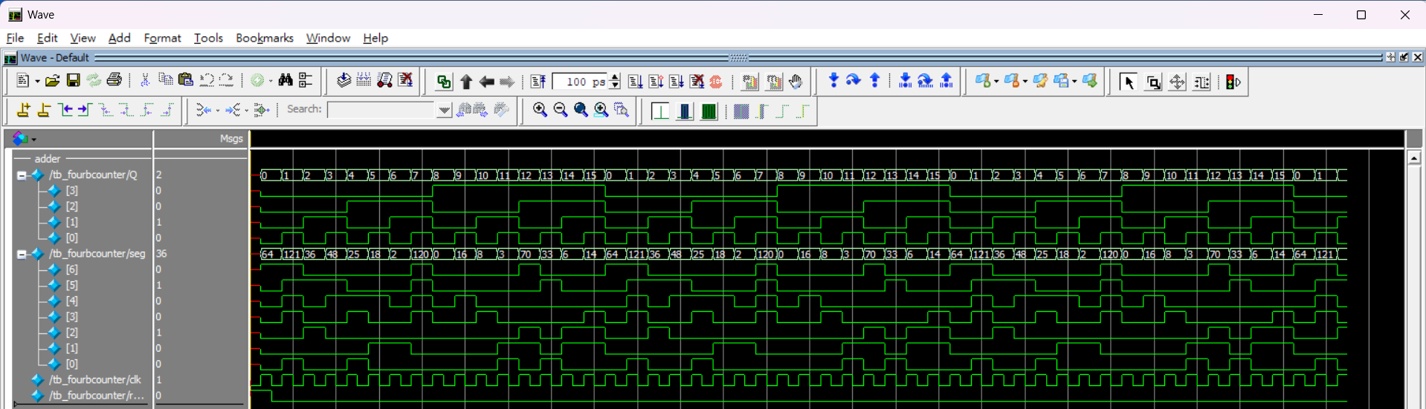

- Lab Summary and Reflection：
Summary:
In this experiment, we utilized Quartus and the Altera DE0 development board to implement synchronous 3-bit and 4-bit counters in SystemVerilog. For the 3-bit counter, we derived the next-state truth table from the state diagram, coded the sequential logic using always_ff constructs, and conducted functional simulation with a dedicated test bench. The outputs Q[2:0] and the overflow flag y were then mapped to onboard LEDs for live verification, and waveform analysis confirmed correct timing and behavior before hardware synthesis. The 4-bit counter followed the same methodology: after describing its state transitions in SystemVerilog and verifying the counting sequence through simulation, we routed the 4-bit binary output through a seven-segment decoder to the SSD. The resulting display on HEX0 validated the design’s correct operation on the DE0 board.

Reflection:
This lab significantly deepened my understanding of sequential logic design and the practical aspects of FPGA implementation. Writing structured always_ff blocks and comprehensive testbenches reinforced best practices in hardware description and simulation-driven verification. Deploying the design to the DE0 board introduced real-world considerations such as precise pin assignments, timing constraints, and external decoder integration, highlighting the importance of hardware-aware design decisions. Reviewing and documenting the screenshots, code, and waveforms in my lab report also underscored the value of thorough documentation and visual evidence when troubleshooting complex digital systems.

